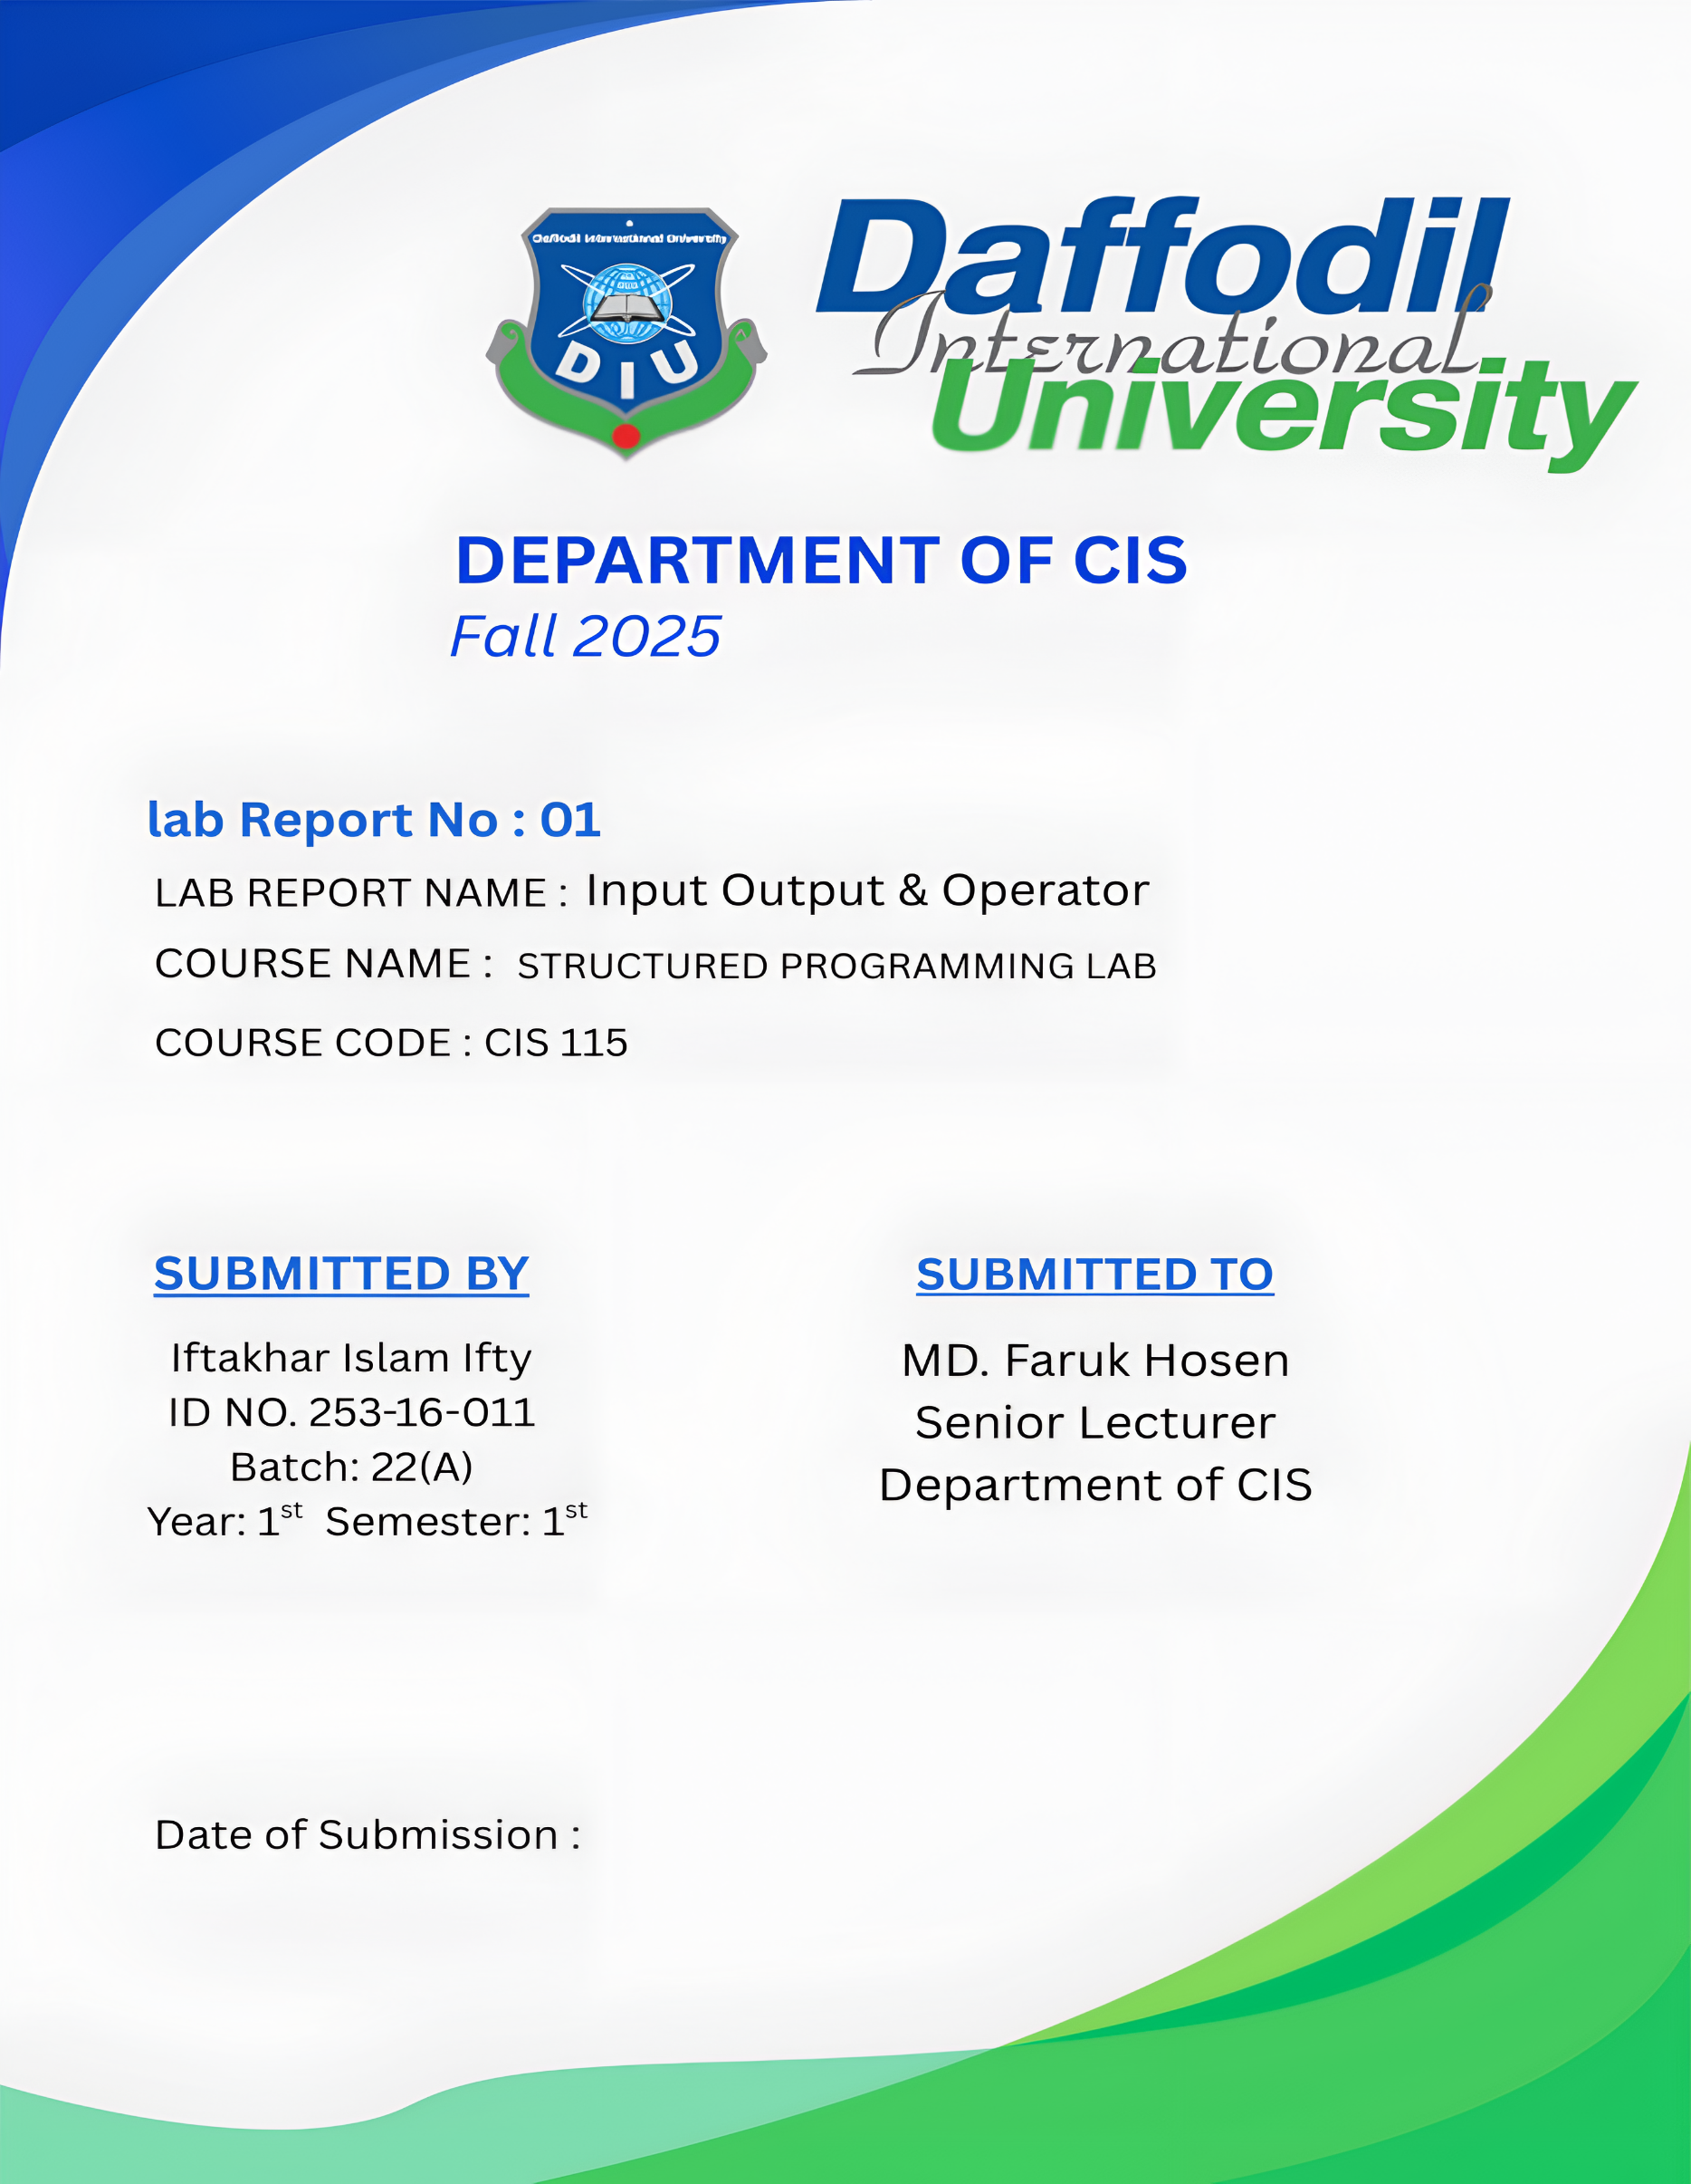

01.10.2025

InijINPUT OUTPUT

Problem No: 01
Problem Name: Write a program that prints your name.

Source Code:

#include <stdio.h>

int main()
{
printf("Iftakhar Islam Ifty");
return 0;
}

Output :
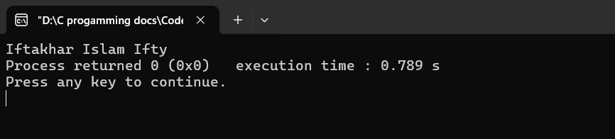

Problem No: 02
Problem Name: An integer variable n contains 5. Write a program that print the
value of n.

Source Code:

#include<stdio.h>
int main()
{
int n;
n=5;
printf("n = %d",n);

return 0;
}

Output :
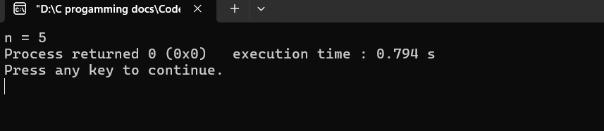

Problem No: 03
Problem Name: Write a program that read and display an integer number.

Source Code:
#include<stdio.h>
int main()
{
int n;
scanf("%d", &n);
printf("Print an integer: %d", n);

return 0;
}

Output :
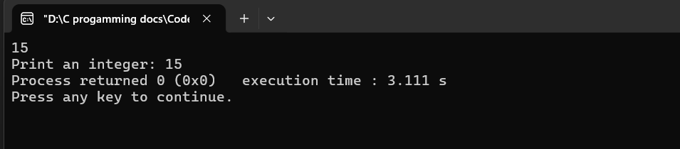

Problem No: 04
Problem Name: Write a program that read and display floating point number.

Source Code:
#include<stdio.h>
int main()
{
float n;
printf("Enter a value: ");
scanf("%f",&n);
printf("The value of n is = %.2f",n);

return 0;
}

Output :
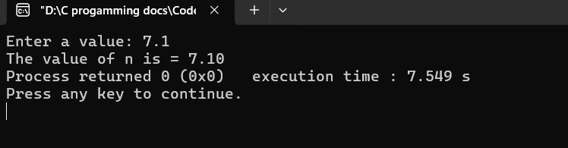

Problem No: 05
Problem Name: Write a program that read and display long number.

Source Code:
#include<stdio.h>
int main()
{
long n;
printf("Enter any long number:");
scanf("%ld",&n);
printf("The value of n is = %ld",n);

return 0;
}

Output :
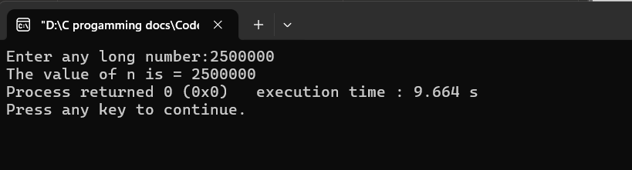

Problem No: 05
Problem Name: Write a program that read and display double number.

Source Code:
#include<stdio.h>
int main()
{
double n;
printf("Enter a double value:");
scanf("%lf",&n);
printf("The value of n is = %.3lf",n);

return 0;
}

Output :
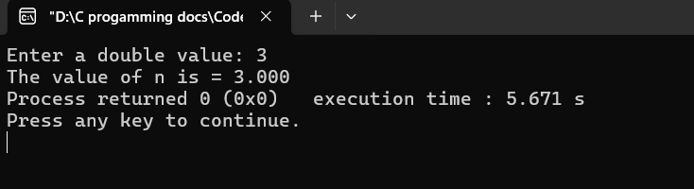

Problem No: 06
Problem Name: Write a program that read and display any character.

Source Code:
#include<stdio.h>
int main()
{
char n;
printf("Enter a character: ");
scanf("%c",&n);
printf("The character is = %c",n);

return 0;
}

Output :
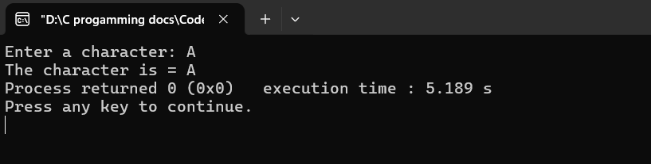

Problem No: 07
Problem Name: Write a program that read ASCII value and display equivalent
character.

Source Code:
#include<stdio.h>
int main()
{
int n;
printf("Enter ASCII value: ");
scanf("%d",&n);
printf("Equivalent Character = %c\n",n);

return 0;
}

Output :
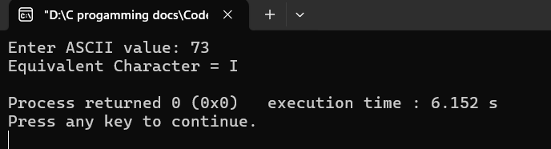

Problem No: 08
Problem Name: Write a program that read any character and display ASCII value.

Source Code:
#include <stdio.h>
int main()
{
char n;
printf("Enter any character: ");
scanf("%c",&n);
printf("Equivalent ASCII value =%d", n);
return 0;
}

Output :
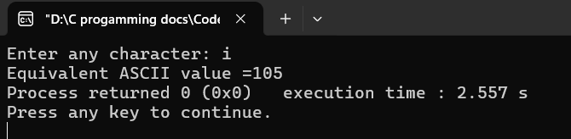

Problem No: 09
Problem Name: Write a program that read any lower case character and display in
upper case.

Source Code:
Outpuy
#include <stdio.h>
int main()
{
char n;
printf("Enter any lower case character: ");
scanf("%c",&n);
printf("%c\n", n-32);
return 0;
}

Output :
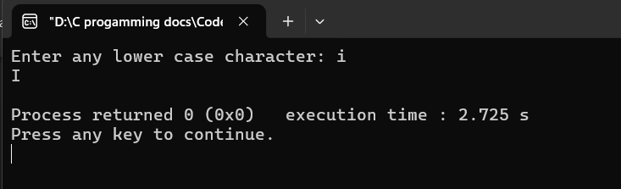

Problem No: 10
Problem Name: Write a program that read any upper case character and display in
lower case.

Source Code:
#include <stdio.h>
int main()
{
char n;
printf("Enter any upper case character: ");
scanf("%c",&n);
printf("%c\n", n+32);
return 0;
}

Output :
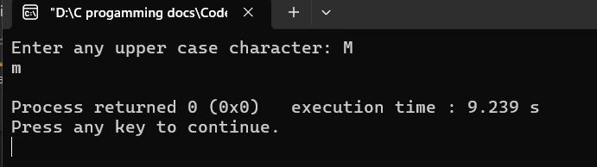

Problem No: 11
Problem Name: Write a program that read any decimal number and display
equivalent octal number.

Source Code:
#include <stdio.h>
int main()
{
int n;
printf("Enter any decimal number: ");
scanf("%d",&n);
printf("Equivalent octal number is %o.", n);
return 0;
}

Output :
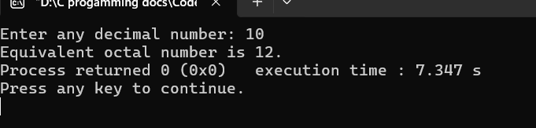

Problem No: 12
Problem Name: Write a program that read any decimal number and display
equivalent hexadecimal number.

Source Code:
#include <stdio.h>
int main()
{
int n;
printf("Enter any decimal number: ");
scanf("%d",&n);
printf("Equivalent hexadecimal number is %X.", n);
return 0;
}

Output :
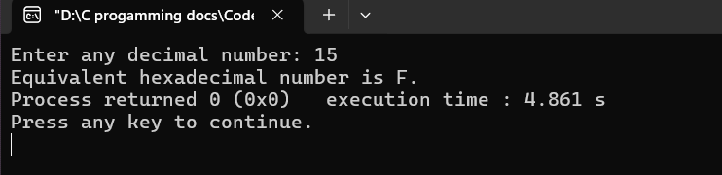

Problem No: 13
Problem Name: Write a program that read any octal number and display equivalent
decimal number.

Source Code:
#include <stdio.h>
int main()
{
int n;
printf("Enter any octal number: ");
scanf("%o",&n);
printf("Equivalent decimal number is %d.", n);
return 0;
}

Output :
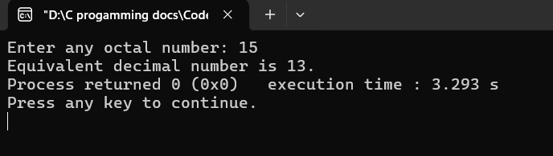

Problem No: 14
Problem Name: Write a program that read any hexadecimal number and display
equivalent decimal number.

Source Code:
#include <stdio.h>
int main()
{
int n;
printf("Enter any hexadecimal number: ");
scanf("%X",&n);
printf("Equivalent decimal number is %d.", n);
return 0;
}

Output :
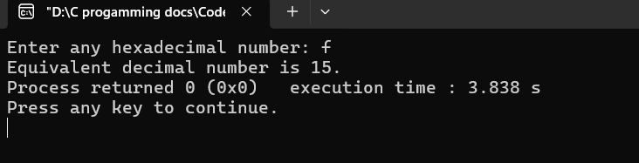

Problem No: 15
Problem Name: Write a program that read and display your name.

Source Code:
#include <stdio.h>
int main()
{

char st[40];

printf("Enter your name:");
scanf("%s",st);
printf("your name is:%s",st);

return 0;

}

Output :
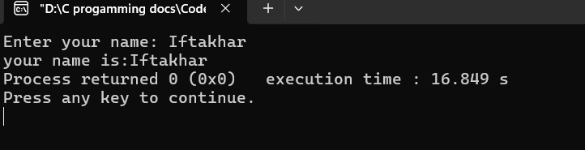

Problem No: 16
Problem Name: Write a program that read and display a line of text.

Source Code:
#include <stdio.h>
int main()
{

char st[100];

printf("Enter any line of text:");
fgets(st,sizeof(st),stdin);
printf("%s",st);

return 0;

}

Output :
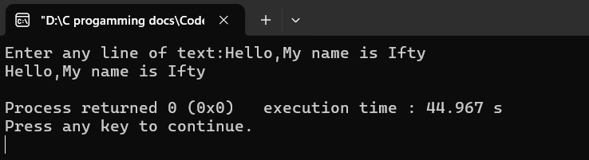

Problem No: 17
Problem Name: Write a program that read any date in the format DD/MM/YY and
displays day, month and year separately.

Source Code:
#include<stdio.h>
int main()
{
int d,m,y;
printf("Enter any date in format(DD/MM/YYYY): ");
scanf("%d/%d/%d", &d,&m,&y);
printf("\nDay= %d\nMonth= %d\nYear= %d",d,m,y );

return 0;
}

Output :
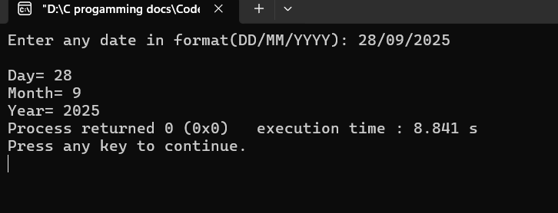

Problem No: 18
Problem Name: Write a program that read any date in the format DD-MM-YYYY
and displays

Source Code:
#include<stdio.h>
int main()
{
int d,m,y;
printf("Enter any date in format(DD-MM-YYYY): ");
scanf("%d-%d-%d", &d,&m,&y);
printf("\nDay= %d\nMonth= %d\nYear= %d",d,m,y );

return 0;
}

Output :
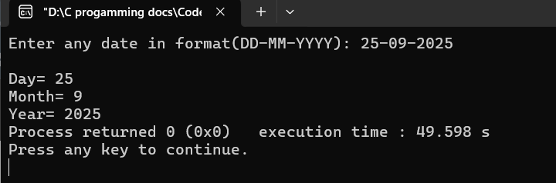

Operator

Problem No: 01
Problem Name: Write a program that read two integers and display sum.

Source Code:
#include<stdio.h>
int main()
{
int a,b;
printf("a=");
scanf("%d",&a);
printf("b=");
scanf("%d",&b);
printf("sum=%d",a+b);
return 0;
}

Output :
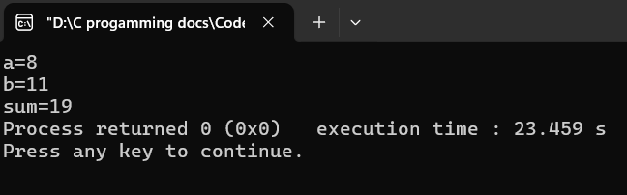
Problem No: 02
Problem Name: Write a program that subtracts two integers.

Source Code:
#include<stdio.h>
int main()
{
int a,b;
printf("a=");
scanf("%d",&a);
printf("b=");
scanf("%d",&b);
printf("subtraction=%d",a-b);
return 0;
}

Output :
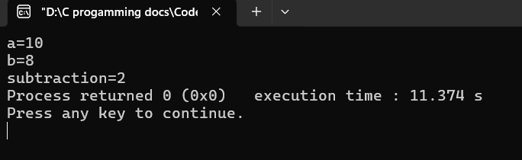

Problem No: 03
Problem Name: Write a program that read two integers and display product.

Source Code:
#include<stdio.h>
int main()
{
int a,b;
printf("a=");
scanf("%d",&a);
printf("b=");
scanf("%d",&b);
printf("product=%d",a*b);
return 0;
}

Output :
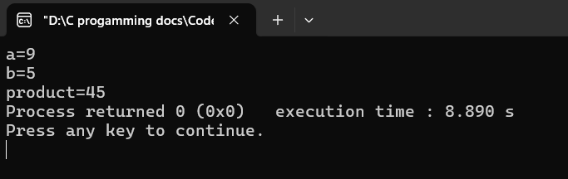

Problem No: 04
Problem Name: Write a program that divide two integers.

Source Code:
#include<stdio.h>
int main()
{
int a,b;
printf("a=");
scanf("%d",&a);
printf("b=");
scanf("%d",&b);
printf("Divison=%d",a/b);
return 0;
}

Output :
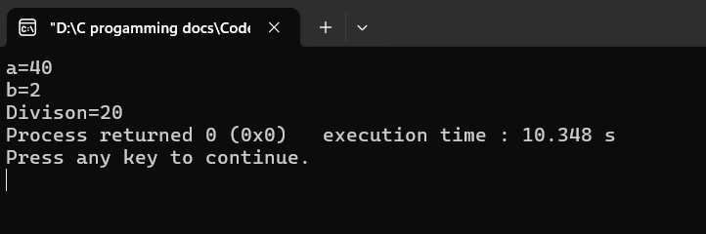

Problem No: 05
Problem Name: Write a program that read and divide two floating point numbers.

Source Code:
#include<stdio.h>
int main()

{
int a,b;
printf("a=");
scanf("%d",&a);
printf("b=");
scanf("%d",&b);
printf("Divison=%.2f",(float)a/b);
return 0;
}

Output :
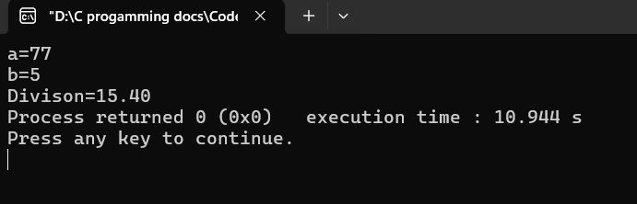

Problem No: 06
Problem Name: Write a program that read two integers and display remainder.

Source Code:
#include<stdio.h>
int main()
{
int a,b;
printf("a=");
scanf("%d",&a);
printf("b=");
scanf("%d",&b);
printf("Mod=%d",a%b);
return 0;
}

Output :
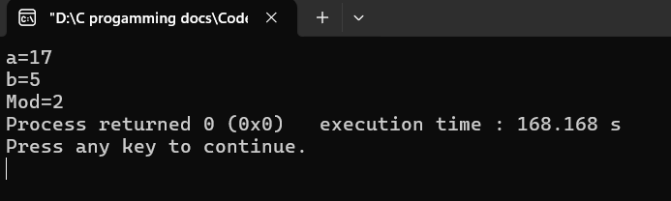

Problem No: 07
Problem Name: Write a program that read radius of a circle and display area.

Source Code:
#include<stdio.h>
int main()

{
int r;
float area;
printf("Radius=");
scanf("%d",&r);
area=3.1416*r*r;
printf("Area=%.2f",area);

return 0;
}

Output :
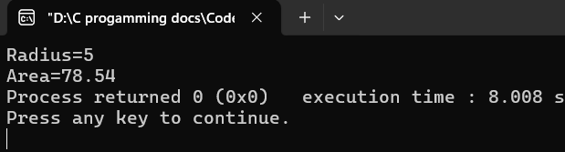

Problem No: 08
Problem Name: Write a program that read temperature in Celsius and display in
Fahrenheit.

Source Code:
#include<stdio.h>
int main()

{
float c,f;
printf("C=");
scanf("%f",&c);
f=(float)9/5*c+32;
printf("F=%f",f);

return 0;
}

Output :
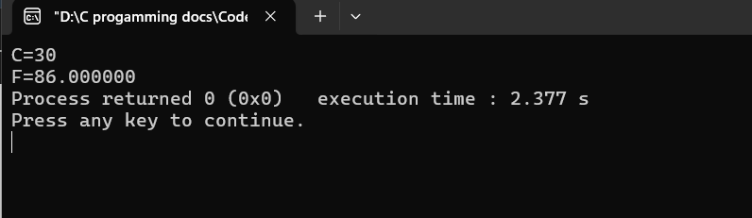

Problem No: 09
Problem Name: Write a program that read temperature in Fahrenheit and display in
Celsius.

Source Code:
#include<stdio.h>
int main()

{
float c,f;

printf("F=");
scanf("%f",&f);
c=(float)5/9*(f-32);
printf("C=%.2f",c);

return 0;
}

Output :
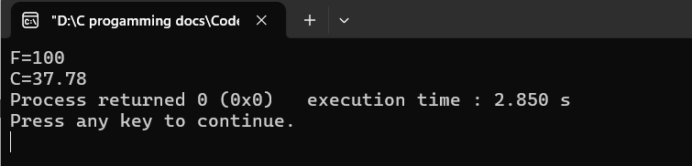
Problem No: 10
Problem Name: Write a program that read two numbers and display bitwise AND.

Source Code:
#include<stdio.h>
int main()

{
int a,b,c;
printf("a=");
scanf("%d",&a);
printf("b=");
scanf("%d",&b);
c=a&b;
printf("%d&%d=%d",a,b,c);

return 0;
}

Output :
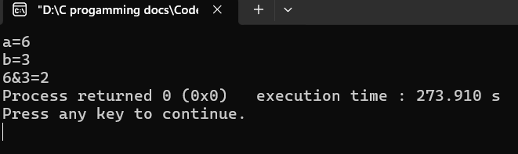
Problem No: 11
Problem Name: Write a program that read two numbers and display bitwise OR.

Source Code:
#include<stdio.h>
int main()

{
int a,b,c;
printf("a=");
scanf("%d",&a);
printf("b=");
scanf("%d",&b);
c=a|b;
printf("%d|%d=%d",a,b,c);

return 0;
}

Output :
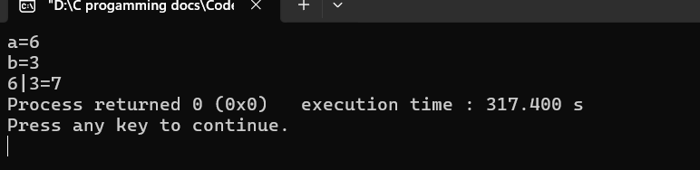
Problem No: 12
Problem Name: Write a program that read two numbers and display bitwise
Exclusive OR.

Source Code:
#include<stdio.h>
int main()
{
int a,b,c;
printf("a=");
scanf("%d",&a);
printf("b=");
scanf("%d",&b);
c=a^b;
printf("%d^%d=%d",a,b,c);

return 0;
}

Output :
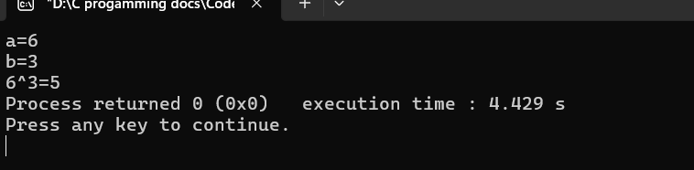
Problem No: 13
Problem Name: Write a program that read a number and divide by two using shift
operator.

Source Code:
#include<stdio.h>
int main()

{
int n;
printf("n=");
scanf("%d",&n);
n=(n>>1);
printf("%d",n);

return 0;
}

Output :
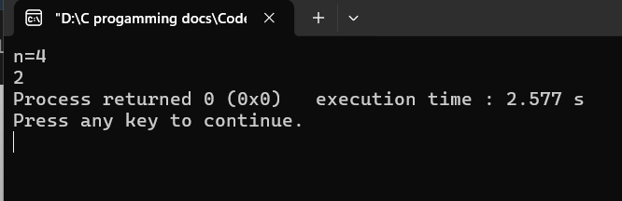
Problem No: 14
Problem Name: Write a program that read a number and multiply by two using
shift operator.

Source Code:
#include<stdio.h>
int main()

{
int n;
printf("n=");
scanf("%d",&n);
n=(n<<1);
printf("%d",n);

return 0;
}

Output :
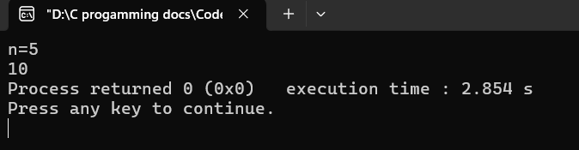

Problem No: 15
Problem Name: Write a program that read a number and multiply by five using
shift operator.

Source Code:
#include<stdio.h>
int main()

{
int n;
printf("n=");
scanf("%d",&n);
n=(n<<2)+n;
printf("%d",n);

return 0;
}

Output :
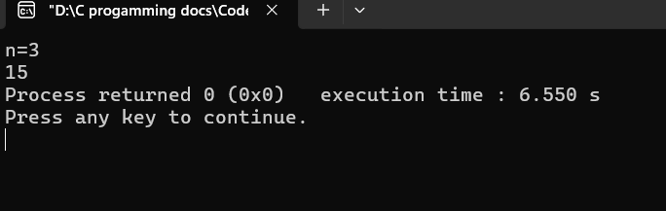
Problem No: 16
Problem Name: Write a program that read a number and mod by 4 using bitwise
AND.

Source Code:
#include<stdio.h>
int main()

{
int n;
printf("n= ");
scanf("%d", &n);
printf("%d", n&3);

return 0;
}

Output :
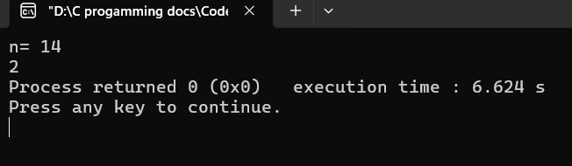

Problem No: 17
Problem Name: Write a program that read a number and mod by 8 using bitwise
AND.

Source Code:
#include<stdio.h>
int main()

{
int n;
printf("n= ");
scanf("%d",&n);
printf("%d",n&7);

return 0;
}

Output :
